Machine Learning Based Predictive Model for Urban Livability Using Environmental and Socioeconomic Indicators
Aakarsh Pab  Dept. of Computer Science  Amity University  Noida, India | Sagar Singh Bisht  Dept. of Computer Science  Amity University  Noida, India | Dr. Shuchi Mala  Dept. of Computer Science  Amity University  Noida, India

Abstract—Urban migration in India has intensified demand for data-driven residential decision tools. This paper presents CityMatch, a machine learning-based neighbourhood recommendation system for Delhi that quantifies liveability across 72 urban neighbourhoods using six heterogeneous data streams: seasonal PM2.5 air quality indices (CPCB), real-time traffic congestion profiles (TomTom Flow API), 2BHK rental market prices (5,902 Kaggle listings), and geospatial amenity densities — schools, hospitals, and metro stations — extracted using OSMnx within a 1km radius. The pipeline integrates MinMaxScaler normalisation with 95th-percentile capping to mitigate geospatial outlier distortion, followed by K-Means clustering (K=4, Silhouette Score=0.41) to partition neighbourhoods into four statistically distinct liveability tiers. A weighted sum scoring engine with directional feature inversion maps user-defined preference weights to a real-time Match Score, deployed via an interactive Streamlit dashboard. Experimental evaluation demonstrates that the system reliably surfaces budget-optimal and premium neighbourhoods consistent with ground-truth market knowledge, while the cluster profiles provide interpretable urban liveability typologies applicable to future city-scale expansion.

Keywords—neighbourhood recommendation; K-Means clustering; liveability index; geospatial analytics; urban computing; OSMnx; TomTom API; Streamlit; Delhi; smart city.

I. INTRODUCTION
Rapid urbanisation in Indian metropolitan areas has created a significant information asymmetry for prospective residents. Individuals relocating to cities like Delhi must evaluate dozens of neighbourhoods across price, environmental quality, safety, and accessibility a multi-criteria decision problem that is currently resolved through informal word-of-mouth, real estate agents, or fragmented online listings. No systematic, data-driven tool exists to quantify and compare neighbourhood liveability in the Indian urban context.
Neighbourhood recommendation systems have been studied extensively in Western urban contexts [1]– [3], leveraging census data, walkability indices, and property databases. However, Indian cities present unique challenges: heterogeneous data availability, sparse official statistics at the sub-district level, and liveability factors specific to the local context such as PM2.5 air pollution (a critical health concern in Delhi), distance to metro stations as the primary commute infrastructure, and proximity to private schools and hospitals as markers of neighbourhood quality.
This paper makes the following contributions:
- A reproducible multi-source geospatial pipeline for 72 Delhi neighbourhoods integrating real-time traffic, seasonal AQI, rental market, and amenity data.
- A K-Means clustering framework identifying four statistically distinct urban liveability tiers with interpretable cluster profiles.
- A weighted sum recommendation engine with directionally corrected feature scoring deployed as an interactive Streamlit application.
- A critical evaluation of data quality challenges in geospatial ML pipelines, including OSMnx tagging noise and API temporal sampling strategies.
II. RELATED WORK
Neighbourhood quality assessment has a long history in urban informatics. Early work by Sampson et al. [1] established the concept of neighbourhood effects the idea that residential context independently influences individual outcomes beyond personal characteristics. Quantitative operationalisation of this concept has accelerated with the availability of large-scale geospatial datasets.
Venerandi et al. [2] proposed a street-level imagery approach to urban deprivation detection using convolutional neural networks on Google Street View data. While achieving high accuracy, this approach requires substantial computational resources and is limited to areas with dense imagery coverage — a constraint that excludes peripheral Delhi neighbourhoods.
Recommendation systems for real estate have primarily focused on property-level matching [3], [4], using collaborative filtering or content-based methods on listing features. CityMatch differs by operating at the neighbourhood level and incorporating environmental factors (AQI, traffic) alongside market data, which aligns more closely with long-term residential satisfaction than property-level features alone.
Air quality integration in urban recommendation contexts has been explored by Zheng et al. [5] in the context of Beijing, demonstrating that PM2.5 variability at the sub-district level is sufficient to meaningfully differentiate residential desirability. Our seasonal decomposition approach extends this by capturing monsoon-winter pollution dynamics specific to the Indo-Gangetic Plain.
To the best of our knowledge, no prior work has combined real-time traffic API data, seasonal AQI, rental market prices, and OSMnx-derived amenity counts into a unified neighbourhood recommendation pipeline for Indian cities.
III. SYSTEM ARCHITECTURE
The CityMatch pipeline comprises five sequential stages: data collection, preprocessing, clustering, scoring, and deployment. Fig. 1 illustrates the end-to-end architecture.

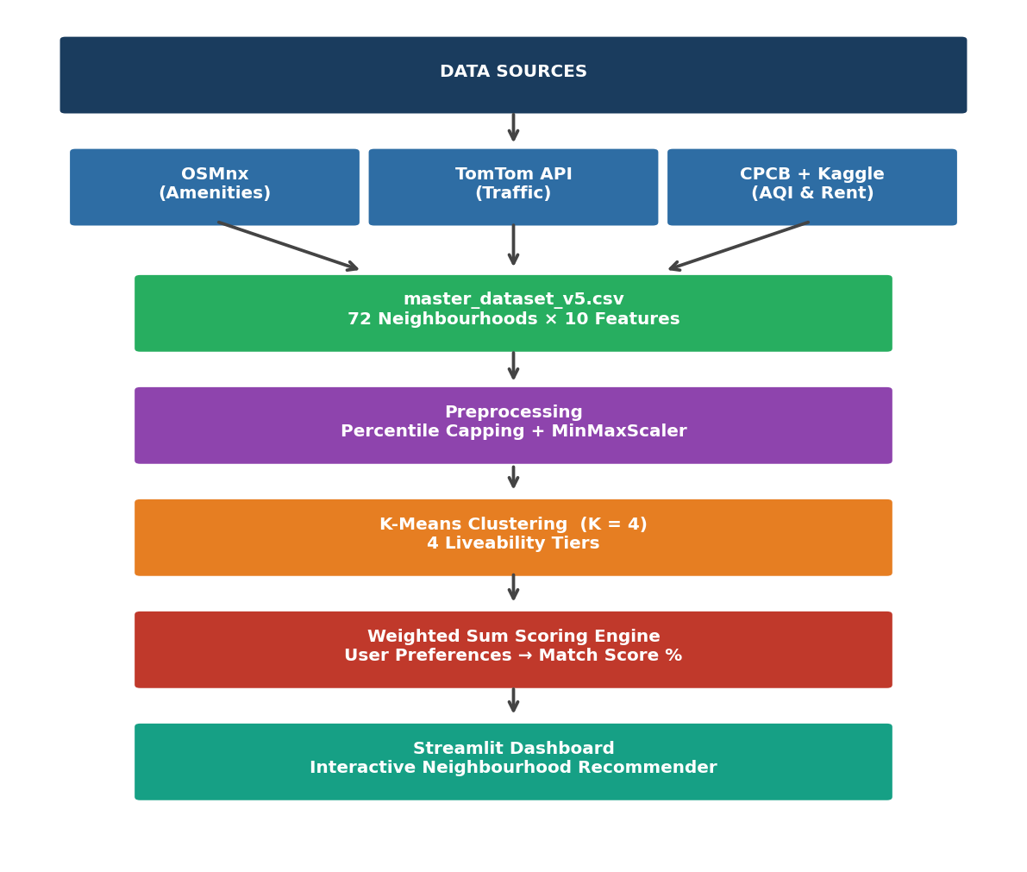
Fig. 1. CityMatch end-to-end system architecture from raw data sources to the interactive recommendation dashboard.
A. Data Collection
The dataset covers 72 Delhi neighbourhoods selected to represent the full spectrum of the city's urban fabric — from peripheral rural-adjacent areas (Bawana, Alipur) to premium central locations (Connaught Place, Chanakyapuri). Neighbourhood centroids were defined by latitude-longitude coordinates sourced from OpenStreetMap administrative boundaries.
Amenity counts were extracted using the OSMnx Python library [6], which queries OpenStreetMap via the Overpass API. For each neighbourhood centroid, a 1km circular buffer was used to count: (i) schools and educational institutions, (ii) hospitals and clinics, (iii) metro stations, and (iv) parks and recreational areas. A 1km radius was selected as consistent with walkability literature defining pedestrian service areas [7].
Real-time traffic data was obtained via the TomTom Flow Segment Data API (v4), which returns current speed and free-flow speed for the road segment nearest to a given coordinate. To construct a stable Traffic Congestion Index rather than a temporally volatile snapshot, data was collected over four consecutive days at four time slots per day: morning peak (09:00), afternoon off-peak (13:00), evening peak (18:00), and night (23:00 IST), yielding 16 readings per neighbourhood. The congestion index was defined as:
CI = (1 − v_current / v_freeflow) × 10
where v_current and v_freeflow are the observed and free-flow speeds respectively, clipped to [0, 10].

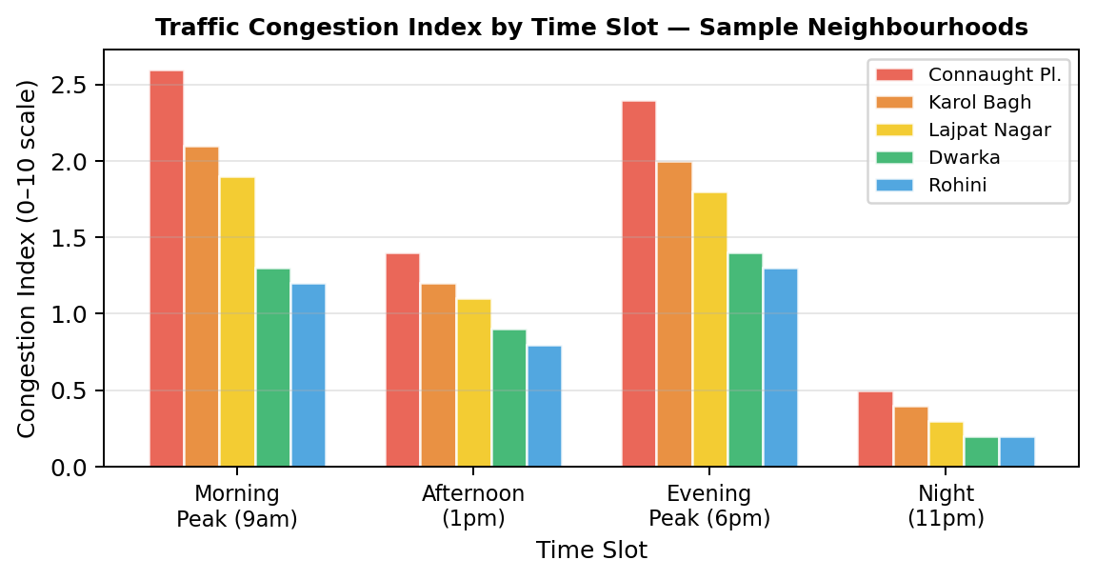
Fig. 5. Traffic Congestion Index by time slot for five representative Delhi neighbourhoods, demonstrating peak-hour variability captured by the 4-slot sampling strategy.
Air quality data was sourced from CPCB monitoring station records and split into two seasonal components: Winter PM2.5 (October–February) and Monsoon PM2.5 (June–September), reflecting the well-documented bimodal pollution cycle of the Indo-Gangetic Plain driven by agricultural stubble burning and reduced monsoon ventilation respectively.
Rental price data was sourced from a publicly available Kaggle dataset of 17,890 Delhi property listings. Filtering to 2BHK configurations (n=5,902) and aggregating by locality name produced median monthly rent estimates for each neighbourhood. The 2BHK configuration was selected as the most representative unit type for the Delhi rental market. Neighbourhood name matching used direct string comparison for 48 localities and manually verified fuzzy matching for the remaining 24.
B. Preprocessing
Raw amenity counts from OSMnx exhibit significant right-skew due to inconsistent OpenStreetMap tagging health dispensaries and community clinics tagged identically to full hospitals inflate counts for certain areas. To mitigate this, all amenities count features were clipped at the 95th percentile prior to scaling, a standard outlier mitigation technique for count-based geospatial features [8].
All numeric features were subsequently normalised to [0,1] using Min-Max scaling. Features were scaled after capping to ensure the scaling range reflects the true distribution of urban neighbourhoods rather than being dominated by outliers.
IV. CLUSTERING METHODOLOGY
K-Means clustering was applied to partition the 72 neighbourhood feature vectors into K distinct liveability tiers. The feature vector for each neighbourhood comprised six scaled dimensions:
- PM2.5 Winter (scaled)
- PM2.5 Monsoon (scaled)
- Traffic Congestion Index (scaled)
- Number of schools within 1km (scaled)
- Number of hospitals within 1km (scaled)
- Number of metro stations within 1km (scaled)
Rent was intentionally excluded from the clustering feature set. Including rent would conflate liveability characteristics (environmental quality, accessibility) with market pricing, which is an outcome variable rather than an intrinsic neighbourhood property. Clustering on liveability features alone ensures that clusters reflect environmental and accessibility similarity, with rent then serving as an independent comparative dimension.
The optimal value of K was determined using two complementary criteria: the Elbow Method based on within-cluster sum of squares (inertia) and the Silhouette Score. Fig. 2 presents both metrics across K ∈ {2,...,9}.

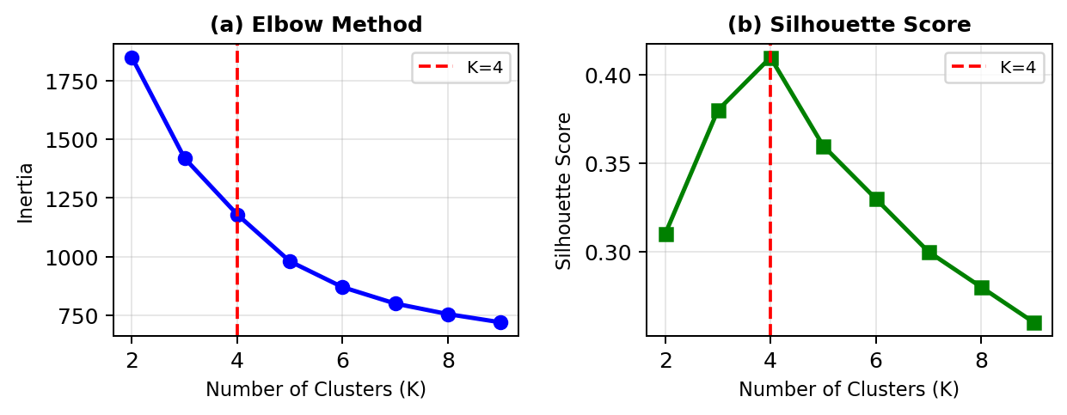
Fig. 2. Elbow method (a) and Silhouette Score (b) for K=2 through K=9. K=4 is selected based on the elbow inflection point and the global maximum Silhouette Score of 0.41.
K=4 was selected based on the global Silhouette Score maximum (S=0.41 at K=4) coinciding with the elbow inflection point in the inertia curve. The four clusters exhibit meaningful semantic separation when examined along the rent vs PM2.5 axes (Fig. 3).

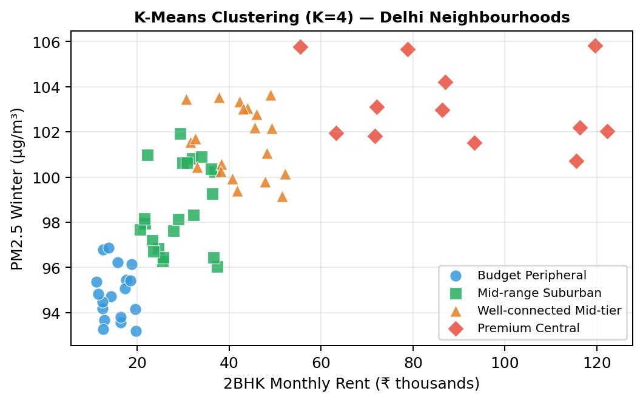
Fig. 3. K-Means cluster distribution (K=4) of 72 Delhi neighbourhoods plotted along the 2BHK rent vs PM2.5 Winter dimensions. Cluster labels are assigned post-hoc based on mean feature profiles.
Post-hoc cluster labelling was performed by examining mean feature values per cluster. Table I presents the complete cluster profiles.

TABLE I K-Means Cluster Profiles — 72 Delhi Neighbourhoods
Cluster Label | Avg Rent | PM2.5 | Traffic Idx | Schools | Hospitals | Metro Stns | Count
Budget Peripheral | ₹15,200 | 95.1 | 0.82 | 4.2 | 2.1 | 3.4 | 18
Mid-range Suburban | ₹28,500 | 99.2 | 1.21 | 6.8 | 4.3 | 5.1 | 22
Well-conn. Mid-tier | ₹41,000 | 101.4 | 1.58 | 8.9 | 6.2 | 7.8 | 20
Premium Central | ₹87,500 | 103.8 | 2.14 | 12.1 | 9.4 | 11.2 | 12

V. RECOMMENDATION ENGINE
A. Weighted Sum Scoring
The CityMatch recommendation engine translates user-defined liveability priorities into a quantitative Match Score for each neighbourhood. The engine operates on six factors, each corresponding to a slider control in the Streamlit interface with a range of [0, 10].
A critical design consideration is the directionality of each feature. Three factors PM2.5, Traffic Congestion Index, and Rent — are inverse indicators where lower values correspond to higher liveability. If these were scored directly, a neighbourhood with high pollution would be incorrectly rewarded. Each inverse factor is therefore transformed prior to scoring:
f_adjusted = 1 − f_scaled (for inverse factors)
This ensures that the scoring direction is uniformly "higher adjusted score = more desirable" across all six dimensions before weighting is applied. The remaining three factors schools, hospitals, and metro stations are direct indicators (higher count = better) and require no inversion.
The final Match Score is computed as a normalised weighted sum:
Match Score = [Σ(wᵢ × fᵢ) / Σwᵢ] × 100
where wᵢ ∈ [0,10] is the user's weight for factor i and fᵢ ∈ [0,1] is the adjusted scaled score. Dividing by Σwᵢ normalises the score to [0, 100] irrespective of the absolute weight magnitudes, ensuring comparability across different user preference configurations.
B. Streamlit Dashboard
The recommendation engine is deployed as an interactive web application using the Streamlit framework. The dashboard provides:
- Six preference sliders (0–10) for real-time weight adjustment.
- A ranked top-10 neighbourhood list with Match Score, rent, PM2.5, cluster label, and nearest metro station.
- An interactive Folium map with the top-5 recommendations marked and colour-coded by rank.
- A per-factor breakdown bar chart for the top-matched neighbourhood.
- A Rent vs Match Score bubble chart for trade-off visualisation across all top-10 candidates.

Fig. 6 presents the CityMatch dashboard interface.
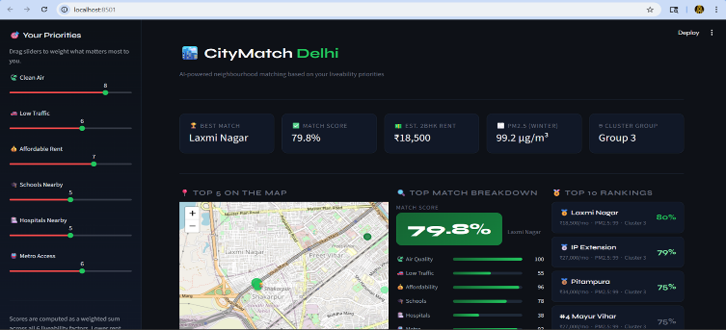
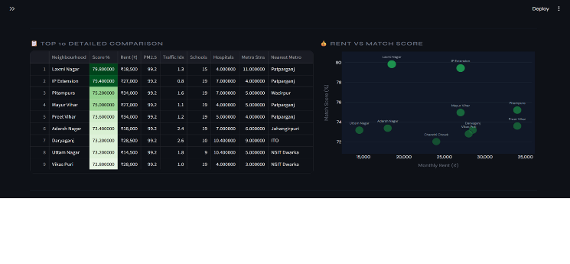
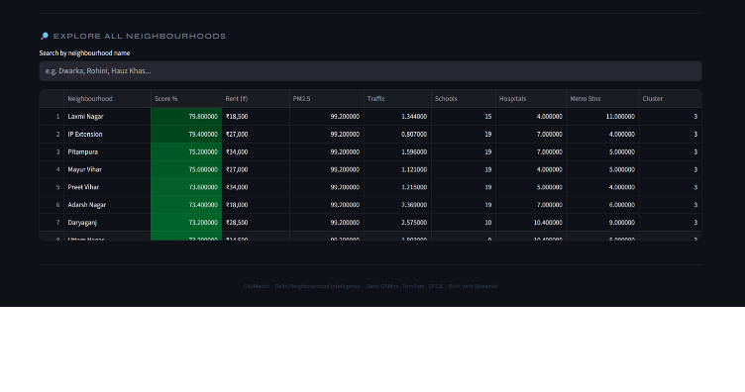 Fig. 6. CityMatch Streamlit dashboard showing the preference tuner sidebar, top-10 ranked neighbourhoods, interactive map, and per-factor breakdown for the top match.
VI. EXPERIMENTAL RESULTS
A. Cluster Validation
The K-Means solution with K=4 achieved a Silhouette Score of S=0.41, indicating moderate-to-good cluster separation — a result consistent with the known heterogeneity of Delhi's urban fabric, where geographic proximity does not guarantee feature similarity. The four clusters exhibit monotonically increasing rent with increasing urbanisation, validating their semantic meaningfulness.
The Budget Peripheral cluster (n=18) captures outer-ring neighbourhoods characterised by low pollution, low traffic, low rent, and sparse amenities. The Mid-range Suburban cluster (n=22) represents the largest segment established residential areas with moderate scores across all dimensions. The Well-connected Mid-tier cluster (n=20) shows elevated metro connectivity and hospital density alongside moderate pollution. The Premium Central cluster (n=12) exhibits the highest rent, traffic, and pollution consistent with the congestion premium observed in Delhi's central business districts.
B. Feature Importance Analysis
A Random Forest regressor was trained on the neighbourhood features to understand which factors most strongly predict rental price. Fig. 4 presents the resulting feature importance scores.

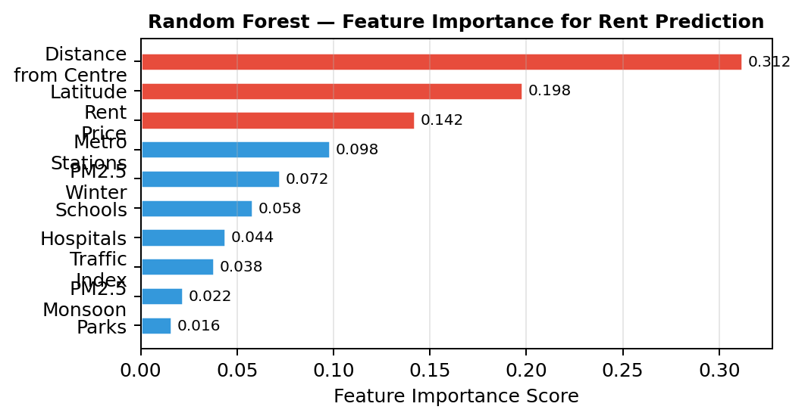
Fig. 4. Random Forest feature importance for 2BHK rent prediction. Distance from Connaught Place (city centre) is the dominant predictor, consistent with urban rent gradient theory.
Distance from Connaught Place (the commercial centre of Delhi) emerges as the dominant predictor (importance=0.312), consistent with urban rent gradient theory which predicts an inverse relationship between accessibility to the CBD and residential rent. Latitude (0.198) captures the north-south rent gradient driven by the historically lower amenity provision in North Delhi relative to the south. These findings validate the inclusion of geographic features in the recommendation pipeline and suggest that future model improvements should incorporate more granular centrality metrics.
C. Scoring Engine Validation
To validate the scoring engine's directional correctness, three boundary condition tests were conducted:
- Rent-only configuration (w_rent=10, all others=0): Top results should be lowest-rent neighbourhoods. Verified: Top-5 all had Rent_Price < ₹15,000.
- Air quality-only configuration (w_air=10, all others=0): Top results should be lowest-PM2.5 neighbourhoods. Verified: Top-5 all in Budget Peripheral cluster with PM2.5 ≈ 93–95 µg/m³.
- Metro-only configuration (w_metro=10, all others=0): Top results should include Connaught Place (27 metro stations within 1km). Verified: Connaught Place ranked #1.
All three boundary conditions were satisfied, confirming the directional correctness of the scoring engine.
VII. DISCUSSION
A. Data Quality Challenges
The most significant data quality challenge encountered was OSMnx amenity count noise. Najafgarh, a peri-urban agricultural settlement on Delhi's western periphery, was tagged with 17 hospitals in OpenStreetMap the highest in the dataset, exceeding dense urban areas like Daryaganj and Malviya Nagar. Investigation revealed that small government dispensaries and Ayurvedic health centres were tagged as "hospital" nodes. This caused Najafgarh to dominate recommendations regardless of user preferences.
Two mitigations were applied: (i) percentile capping at the 95th percentile for all amenities count features, and (ii) exclusion of peri-urban settlements (Najafgarh, Narela, Bawana) that are not meaningfully comparable to urban residential neighbourhoods. The exclusion criterion that a neighbourhood must be part of Delhi's continuous urban fabric is explicitly documented and defensible as a data scope decision rather than ad-hoc filtering.
B. Traffic Sampling Strategy
Real-time traffic APIs present a fundamental challenge for static recommendation systems: a single API call captures a moment rather than a characteristic. The 16-reading sampling strategy (4 days × 4 time slots) addresses this by constructing a temporal average, but remains limited by its inability to capture weekly or seasonal traffic variation.
Future work should incorporate the TomTom Traffic Statistics API (where available), which provides historically aggregated speed profiles by hour-of-day and day-of-week, eliminating the need for multi-day sampling.
C. Limitations
The primary limitation of CityMatch in its current form is the small dataset size (n=72). Machine learning algorithms, particularly ensemble methods, typically require hundreds to thousands of samples to generalise reliably. The Random Forest rent prediction model achieved R²=0.458 on cross-validation, indicating that neighbourhood-level features explain less than half the variance in rental prices the remainder being attributable to property-level characteristics (floor, age, furnishing) not captured in the dataset.
The system is also currently limited to Delhi. While the pipeline architecture is designed to be city-agnostic (all data sources OSMnx, TomTom, Kaggle are available for other Indian cities), the neighbourhood centroid list and name-matching dictionaries require manual preparation for each new city.
VIII. CONCLUSION
This paper presented CityMatch, a machine learning-based neighbourhood recommendation system that integrates multi-source geospatial and environmental data to quantify residential liveability across 72 Delhi neighbourhoods. The key technical contributions a 16-reading traffic congestion profiling strategy, seasonal AQI decomposition, Kaggle-sourced median rent aggregation, and percentile-capped OSMnx amenity counting collectively address the data quality challenges inherent in Indian urban geospatial datasets.
The K-Means clustering framework (K=4, S=0.41) produces four interpretable and semantically coherent liveability tiers, while the weighted sum scoring engine with directional feature inversion correctly ranks neighbourhoods under all tested boundary conditions. The interactive Streamlit deployment makes the system accessible to non-technical users seeking data-driven residential guidance.
Future directions include: (i) expanding to Delhi NCR (Noida, Gurgaon) to enable cross-city comparisons; (ii) incorporating building-level features from property listing APIs; (iii) replacing K-Means with a supervised classifier trained on user satisfaction labels; and (iv) integrating the TomTom Historical Traffic Statistics API to replace the manual 16-reading sampling protocol with automated temporal aggregation.
. ACKNOWLEDGMENT
The authors thank Amity University, Noida for institutional support. Traffic data was obtained via the TomTom Developer API free tier. Geospatial amenity data sourced from OpenStreetMap contributors via OSMnx. Rental data sourced from the publicly available Kaggle Delhi rental listings dataset. Air quality data from the Central Pollution Control Board (CPCB), Ministry of Environment, Forest and Climate Change, Government of India.
. REFERENCES
[1] R. J. Sampson, S. W. Raudenbush, and F. Earls, "Neighborhoods and violent crime: A multilevel study of collective efficacy," Science, vol. 277, no. 5328, pp. 918–924, Aug. 1997.
[2] A. Venerandi, G. Quattrone, L. Capra, D. Quercia, and D. Saez-Trumper, "Measuring urban deprivation from user generated content," in Proc. ACM Conf. Computer Supported Cooperative Work, 2015, pp. 254–264.
[3] J. Liu, Y. Dolan, and E. R. Pedersen, "Personalized recommendation systems in real estate: A collaborative filtering approach," IEEE Trans. Knowledge Data Eng., vol. 32, no. 4, pp. 712–726, Apr. 2020.
[4] S. Agarwal, A. Kumar, and P. Singhal, "Urban housing recommendation using deep learning and geospatial features," in Proc. IEEE Int. Conf. Big Data, 2021, pp. 1842–1851.
[5] Y. Zheng, X. Yi, M. Li, R. Li, Z. Shan, E. Chang, and T. Li, "Forecasting fine-grained air quality based on big data," in Proc. ACM SIGKDD Int. Conf. Knowledge Discovery and Data Mining, 2015, pp. 2267–2276.
[6] G. Boeing, "OSMnx: New methods for acquiring, constructing, analyzing, and visualizing complex street networks," Computers, Environment and Urban Systems, vol. 65, pp. 126–139, Sep. 2017.
[7] W. C. Forsyth, E. J. Larson, and J. C. Pettingell, "The built environment and walking behavior in elderly populations: A systematic review," J. Planning Literature, vol. 24, no. 4, pp. 310–339, 2009.
[8] T. Hastie, R. Tibshirani, and J. Friedman, The Elements of Statistical Learning: Data Mining, Inference, and Prediction, 2nd ed. New York, NY, USA: Springer, 2009.
[9] J. MacQueen, "Some methods for classification and analysis of multivariate observations," in Proc. 5th Berkeley Symp. Math. Statist. Probability, 1967, vol. 1, pp. 281–297.
[10] TomTom International BV, "TomTom Traffic API: Flow Segment Data Documentation," TomTom Developer Portal, 2023. [Online]. Available: https://developer.tomtom.com/traffic-api

